**INSTITUTE OF SCIENCE & TECHNOLOGY, BHOPAL**

**DEPARTMENT OF INFORMATION TECHNOLOGY**

**LAB MANUAL**

**Name: Database Management System**

**Course Code: IT- 225**

**Course: B.TECH**

**Session:**

**Prepared By- Submitted to:-**

**Roll No**

**Name**

**TABLE OF CONTENTS**

**Index**

|  |  |  |  |
| --- | --- | --- | --- |
| **Sr No.** | **Experiment** | **Submission Date** | **Remark** |
| **1** | Draw database & types of database using Smart Draw Tool. |  |  |
| **2** | Draw 2 Tier- 3 Tier Architecture using Smart Draw Tool. |  |  |
| **3** | Draw Schema Architecture with Smart Draw Tool. |  |  |
| **4** | Draw DBMS detailed architecture with Smart Draw Tool. |  |  |
| **5** | Draw Data Independence architecture using Smart Draw Tool. |  |  |
| **6** | Draw Data models Category using Smart Draw Tool. |  |  |
| **7** | Draw Specialization Generalization & Aggregation with Smart Draw Tool. |  |  |
| **8** | Draw ER Diagram of College Database and Bank Database with Smart Draw Tool. |  |  |
| **9** | To study about the DDL commands. |  |  |
| **10** | To study about the DML commands. |  |  |
| **11** | To study about Aggregate Functions |  |  |
| **12** | To study about the Set Operations. |  |  |
| **13** | To perform JOIN operations. |  |  |
| **14** | To study View operations. |  |  |
| **15** | To study about the stored procedures  . |  |  |

#### Experiment - One

1. **Objective:** Draw database & types of database using Smart Draw tool.
2. **Description:**

A **database** is an organized collection of data. The data is typically organized to model aspects of reality in a way that supports processes requiring information. Formally, a "database" refers to a set of related data and the way it is structured or organized. Access to this data is usually provided by a "database management system" (DBMS) consisting of an integrated set of computer software that allows [users](http://en.wikipedia.org/wiki/User_%28computing%29) to interact with one or more databases and provides access to all of the data contained in the database (although restrictions may exist that limit access to particular data). The DBMS provides various functions that allow entry, storage and retrieval of large quantities of information as well as provide ways to manage how that information is organized

Large commercial databases may exist in two different Topologies.

* Centralised - where the database is physically in one location and users typically use an Internet connection to access it. Banks (such as ANZ) tend to use centralised databases.
* Distributed - Where the database is in many locations often where you have a national or international company and customers tend to regularly interact with a local branch. For example: Google uses Big-Table a distributed DBMS as searching tends to be by users in a particular region of the world.

In both cases the database "looks" like one database

1. **Result (Snapshot)**

#### 

#### Experiment - Two

* 1. **Objective:** Draw 2 Tier- 3 Tier Architecture with Smart Draw tool.
  2. **Description:**

**Two-Tier Architecture:**

The two-tier architecture is like client server application. The direct communication takes place between client and server. There is no intermediate between client and server.

1. Database (Data tier)
2. Client Application (Client tier)

So, in client application the client writes the program for saving the record in SQL Server and thereby saving the data in the database.

Advantages**:**

1. Understanding and maintenances is easier.

**Disadvantages**:

1. Performance will be reduced when there are more users.

**Three-Tier Architecture:**

Three tier architecture having three layers. They are

1. Client layer
2. Business layer
3. Data layer

Client layer: Here we design the form using textbox, label etc.

Business layer: It is the intermediate layer which has the functions for client layer and it is used to make communication faster between client and data layer. It provides the business processes logic and the data access.

Data layer: it has the database.

**Advantages**

1. Easy to modify with out affecting other modules
2. Fast communication
3. Performance will be good in three tier architecture.

**( c )** **Result (Snapshot)**

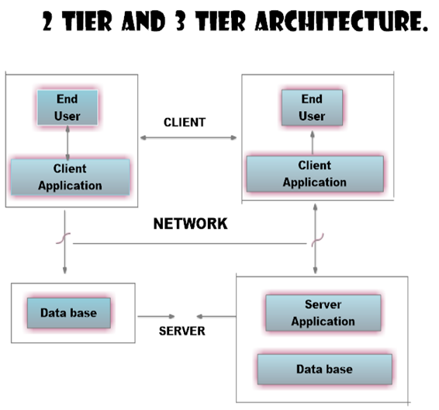

**Experiment - Three**

#### (a) Objective: Draw [Schema Architecture with Smart Draw tool.](https://sites.google.com/site/09cegit/information-security/writeacprogramforrsaalgorithm)

**(b) Description:**

Data are actually stored as bits, or numbers and strings, but it is difficult to work with data at this level. It is necessary to view data at different levels of abstraction.

Schema:

* Description of data at some level. Each level has its own schema.

We will be concerned with three forms of schemas:

* physical,
* conceptual, and
* external.

**Physical Data Level**

The **physical schema** describes details of how data is stored: files, indices, etc. on the random access disk system.  It also typically describes the record layout of files and type of files (hash, b-tree, flat).

**Conceptual Data Level**

Also referred to as the Logical level

Hides details of the physical level.

* In the relational model, the conceptual schema presents data as a set of tables.

**External Data Level**

In the relational model, the **external schema** also presents data as a set of relations. An external schema specifies a **view** of the data in terms of the conceptual level. It is tailored to the needs of a particular category of users. Portions of stored data should not be seen by some users and begins to implement a level of security and simplifies the view for these users

**(c)** **Result (Snapshot)**

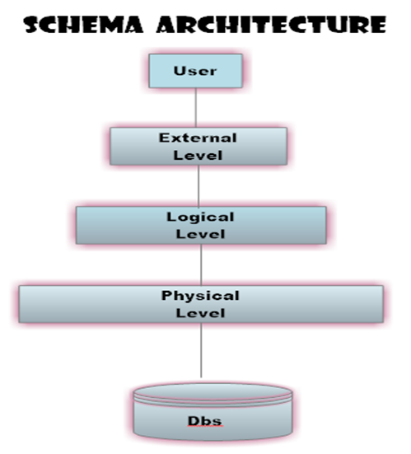

**Experiment - Four**

**(a) Objective:** Draw DBMS detailed architecture with Smart Draw tool

**(b)** **Description:**

A **database system** is partitioned into modules that deal with each of the responsibilities of the overall system.

The functional components of a database system can be broadly divided into the storage manager and the query processor components. Storage manager: The storage manager is important because database typically require a large amount of storage space. Corporate database range in size from hundreds of gigabytes to for the largest database terabytes of data. Since the main memory of computer cannot store this much information, the information is stored on disks. Data are moved between disk storage and main memory as needed. Since the movement of data to and from disk is slow relative to the speed of the central processing unit, it is imperative that the database system structure the data so as to minimize the need to move data between disk and main memory.

A storage manager is a program module that provides the interface between the low level data stored in the database and the application programs and queries submitted to the system. The storage manager is responsible for the interaction with the file manager. The raw data are stored on the disk using the file system, which is usually provided by a conventional operating system. The storage manager translates the various DML statements into low-level File system commands. Thus, the storage manager is responsible for storing, retrieving, and updating data in the data base.

The storage manager components include:

i)  Authorization and integrity manager: Which tests for the satisfaction of integrity constraints and checks the authority of users to access data.

ii)   Transaction manager: Which ensures that the database remains in a consistent (correct) state despite system failures, and that concurrent transaction executions proceed without conflicting.

iii) File manager: Which manages the allocation of space on disk- storage and the data structures used to represent information stored on disk.

iv) Buffer manager: Which is responsible for fetching data from disk storage into main memory and deciding what data to cache in main memory. The buffer manager is a critical part of the data base system, since it enables the data base to handle data sizes that are much larger than the size of main memory.

The storage manager implements several data structures as part of the physical system implementation.

i)   Data files which store the data base itself.

ii)   Data dictionary which stores metadata about the structure of the database, in particular the schema of the data base.

iii) Indices which provide fast access to data items that hold particular values.

 The query processor: Query processor helps the database system simplify and facilitate access to data. The job of the database system to translate update and queries written in a non procedural language, at the logical level, into an efficient sequence of operations at the physical level.

**(c) Result (Snapshot)**

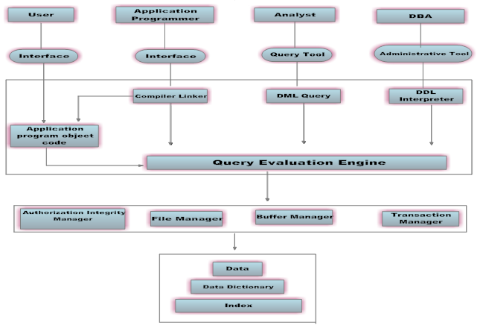

**Experiment - Five**

**(a) Objective:** Draw Data Independence architecture with Smart Draw tool.

**(b)** **Description:**

**Data independence** is the type of [data](http://en.wikipedia.org/wiki/Data) transparency that matters for a centralized [DBMS](http://en.wikipedia.org/wiki/Database_management_system). It refers to the immunity of user [applications](http://en.wikipedia.org/wiki/Application_software) to changes made in the definition and organization of data. Data independence can be explained as follows: Each higher level of the data architecture is immune to changes of the next lower level of the architecture.

## Data Independence Types

The ability to modify schema definition in one level without affecting schema definition in the next higher level is called data independence. There are two levels of data independence, they are Physical data independence and Logical data independence.

1. Physical data independence is the ability to modify the physical schema without causing application programs to be rewritten. Modifications at the physical level are occasionally necessary to improve performance. It means we change the physical storage/level without affecting the conceptual or external view of the data. The new changes are absorbed by mapping techniques.
2. Logical data independence is the ability to modify the logical schema without causing application program to be rewritten. Modifications at the logical level are necessary whenever the logical structure of the database is altered (for example, when money-market accounts are added to banking system). Logical Data independence means if we add some new columns or remove some columns from table then the user view and programs should not change. It is called the logical independence. For example: consider two users A & B. Both are selecting the empno and ename. If user B add a new column salary in his view/table then it will not effect the external view user; user A, but internal view of database has been changed for both users A & B. Now user A can also print the salary. It means if we change in view then program which use this view need not to be changed.

**Result (Snapshot)**

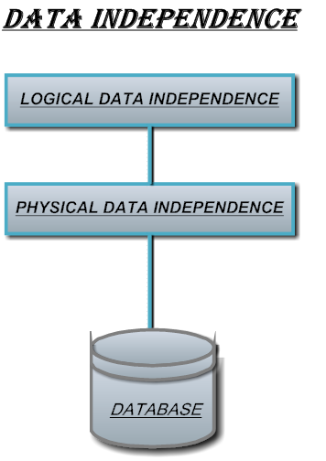

**Experiment - Six**

**(a) Objective:** Draw Data Models Category using Smart Draw tool

**(b)** **Description:**

A **database model** is a type of [data model](http://en.wikipedia.org/wiki/Data_model) that determines the logical structure of a [database](http://en.wikipedia.org/wiki/Database) and fundamentally determines in which manner [data](http://en.wikipedia.org/wiki/Data) can be stored, organized, and manipulated. The most popular example of a database model is the [relational model](http://en.wikipedia.org/wiki/Relational_model), which uses a table-based format. Common [logical data models](http://en.wikipedia.org/wiki/Logical_data_model) for databases include:

* [Hierarchical database model](http://en.wikipedia.org/wiki/Hierarchical_database_model)
* [Network model](http://en.wikipedia.org/wiki/Network_model)
* [Relational model](http://en.wikipedia.org/wiki/Relational_model)
* [Entity–relationship model](http://en.wikipedia.org/wiki/Entity%E2%80%93relationship_model)
  + [Enhanced entity–relationship model](http://en.wikipedia.org/wiki/Enhanced_entity%E2%80%93relationship_model)

# Hierarchical database model

A hierarchical database model is a [data model](http://en.wikipedia.org/wiki/Data_model) in which the data is organized into a [tree](http://en.wikipedia.org/wiki/Tree_data_structure)-like structure. The data is stored as records which are connected to one another through links. A record is a collection of fields, with each field containing only one value. The entity type of a record defines which fields the record contains.

# Network model

The network model is a [database model](http://en.wikipedia.org/wiki/Database_model) conceived as a flexible way of representing objects and their relationships. Its distinguishing feature is that the schema, viewed as a graph in which object types are nodes and relationship types are arcs, is not restricted to being a hierarchy or [lattice](http://en.wikipedia.org/wiki/Lattice_graph).

# Relational model

The relational model for [database](http://en.wikipedia.org/wiki/Database) management is a [database model](http://en.wikipedia.org/wiki/Database_model) based on [first-order predicate logic](http://en.wikipedia.org/wiki/First-order_logic), first formulated and proposed in 1969 by [Edgar F. Codd](http://en.wikipedia.org/wiki/Edgar_F._Codd). In the relational model of a database, all data is represented in terms of [tuples](http://en.wikipedia.org/wiki/Tuple), grouped into [relations](http://en.wikipedia.org/wiki/Relation_%28database%29). A database organized in terms of the relational model is a [relational database](http://en.wikipedia.org/wiki/Relational_database).

# Entity–relationship model

In [software engineering](http://en.wikipedia.org/wiki/Software_engineering), an entity–relationship model (ER model) is a [data model](http://en.wikipedia.org/wiki/Data_modeling) for describing the data or information aspects of a business domain or its process requirements, in an abstract way that lends itself to ultimately being implemented in a [database](http://en.wikipedia.org/wiki/Database) such as a [relational database](http://en.wikipedia.org/wiki/Relational_database). The main components of ER models are [entities](http://en.wikipedia.org/wiki/Entities) (things) and the relationships that can exist among them.

**(c) Result (Snapshot)**

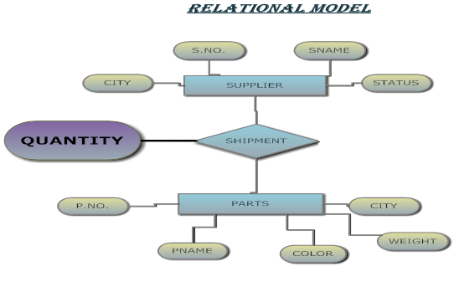





**Experiment - Seven**

**(a) Objective:** Draw Specialization Generalization & Aggregation with Smart Draw tool.

**(b) Description:**

**Specialization is** top down manner, in which an entity set may include sub groupings of entities that are distinct in some way from other entities in the set. For instance, a subset of entities within an entity set may have attributes that are not shared by all the entities in the entity set.

**Generalization is b**ottom-up manner, in which multiple entity sets are synthesized into a higher-level entity set on the basis of common features.

**Aggregation** is an abstraction in which relationship sets (along with their associated entity sets) are treated as higher-level entity sets, and can participate in relationships.

**(c) Result (Snapshot)**

**Specialization:-**



**Generalization:-**



**Experiment - Eight**

#### (a) Objective: Draw ER Diagram of College Database and Bank Database

**(b)  Description:**

Assume all entities , attributes and relationship. Represent all cardinality and constraints for the following databases-

* 1. College Database
  2. Bank Database

**(c) Result (Snapshot)**

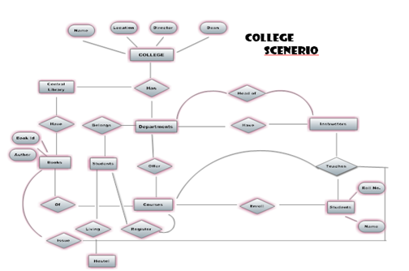

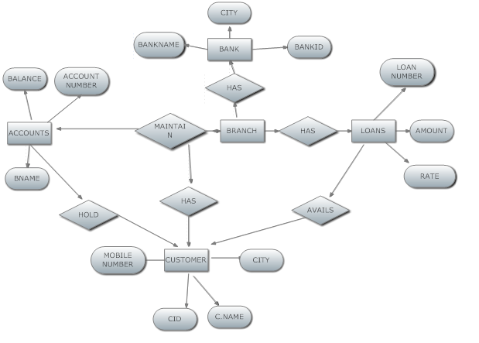**Bank Scenerio:-**

**Experiment - Nine**

**(a) Objective**: To study about the DDL commands in RDBMS.

**(b) Coding & Result:**

**Table Creation:**

Syntax: **Create** **table** table-name(A1D1,A2D2……….AnDn)

Description: To create a new table.



**Table Description**:

Syntax: **Desc** table-name.

Description: To display the structure of the table.

**Table Deletion**:

Syntax:  **Drop table** table-name

Description: To delete the table.

**Table Renaming:**

Syntax: **Alter table** old-table-name **rename to** new-table-name

Description: To rename the table .

**Rename Column:**

Syntax: **Alter table** table-name **rename column** old-column-name to New-column-name

Description: To rename the column in the table.

**Adding one Column**:

Syntax: **Alter table** table-name **add** A D

Description: To alter the table by adding one column

**Deleting One Column:**

Syntax: **Alter table** table-name **drop column** A

Description: To delete one column from the table.

**Datatype or Domaintype modification:**

Syntax: **Alter table** table-name **modify**(A1 new data-type(size),……..An new data-type(size))

Description: To change the datatype or domaintype.

**Table Truncation:**

Syntax: **Truncate table** table-name

Description: To delete all the records from the table.

**Example:-**

**Creating the table**:

Table created.

**Description of the table**:

Desc Table name

**Output-(Snapshot)**

**Renaming the column:**

### Alter table student rename column course to degree

Table altered.

Desc Table_name

**Adding one column:**

Alter table Table_name add column_name datatype

Table altered.

Desc Table_name

**Deleting one column:**

Alter table Table_name drop column column_name

Table altered.

Desc Table_name

**Domain type modification:**

### Desc Table_name

**Table renaming**:

Alter table Table_name rename to new_table_name

Table altered

Desc Table_name

**Table truncation:**

# Truncate table class

Table truncated.

C**reate table with primary keys:**

Table deletion:

Drop table class

Table dropped.

**Result(Snapshot)**

Thus the DDL commands were executed.

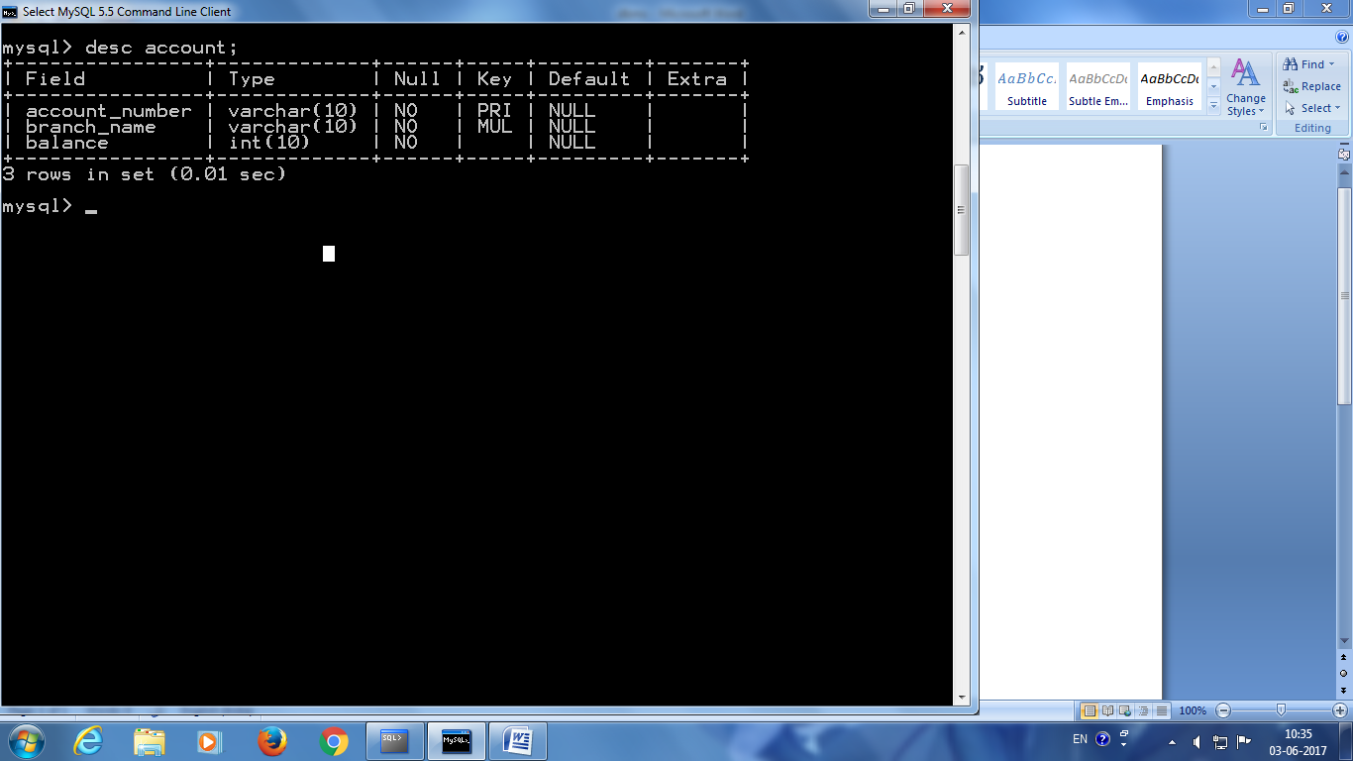**Table created (table name - account)**

**New Column added to the table account**

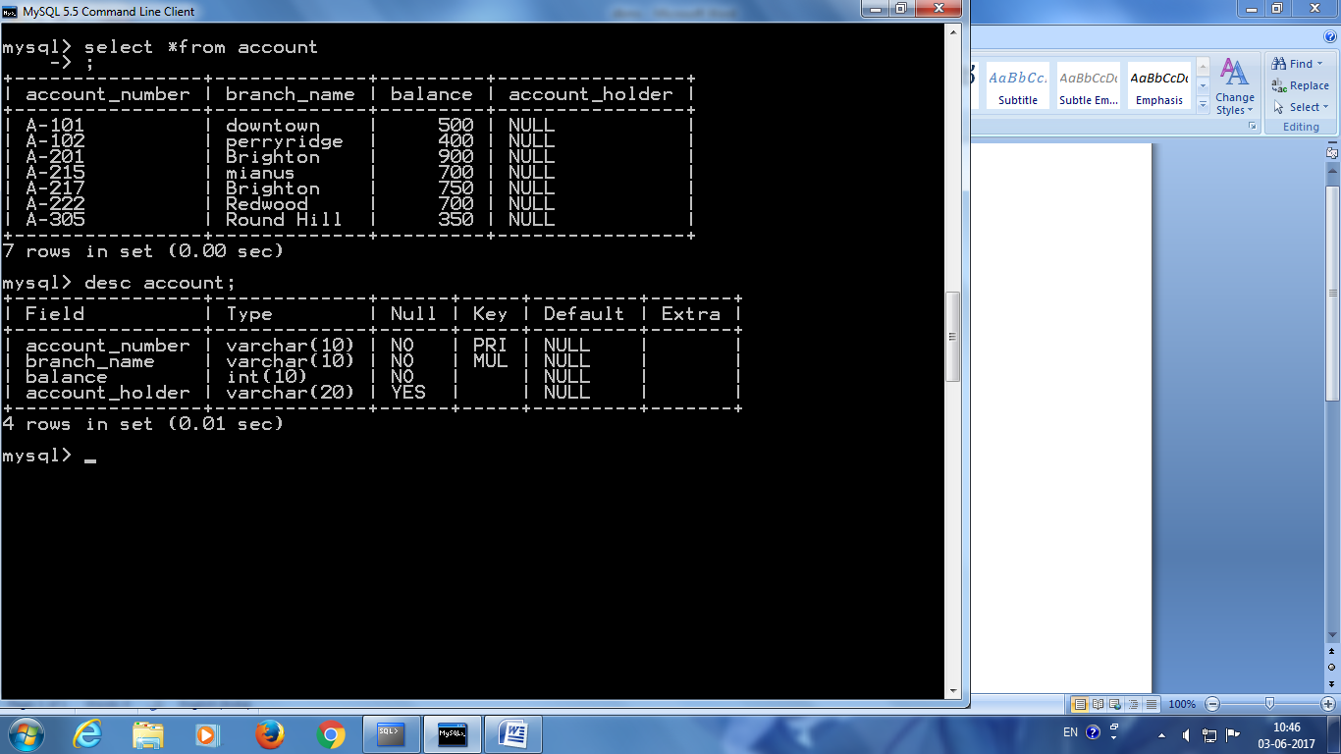

**Column dropped from table account**

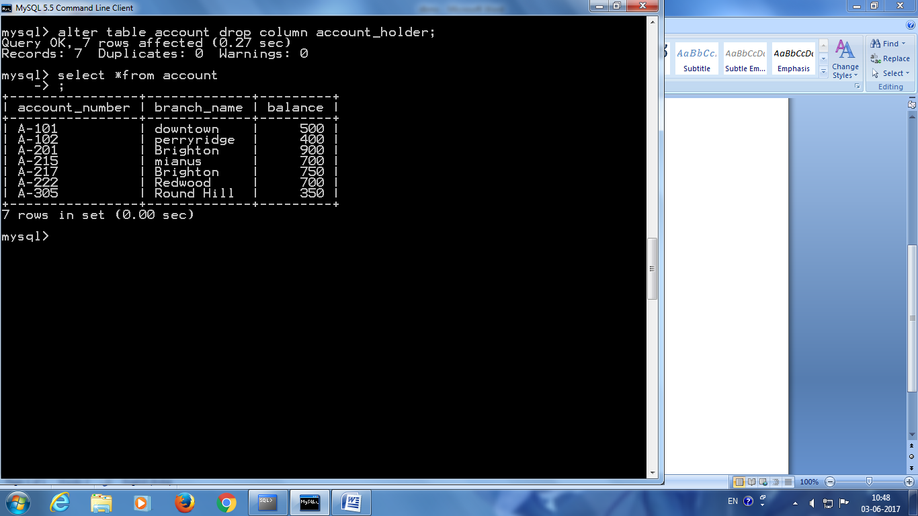

**Table name changed from account to account1**

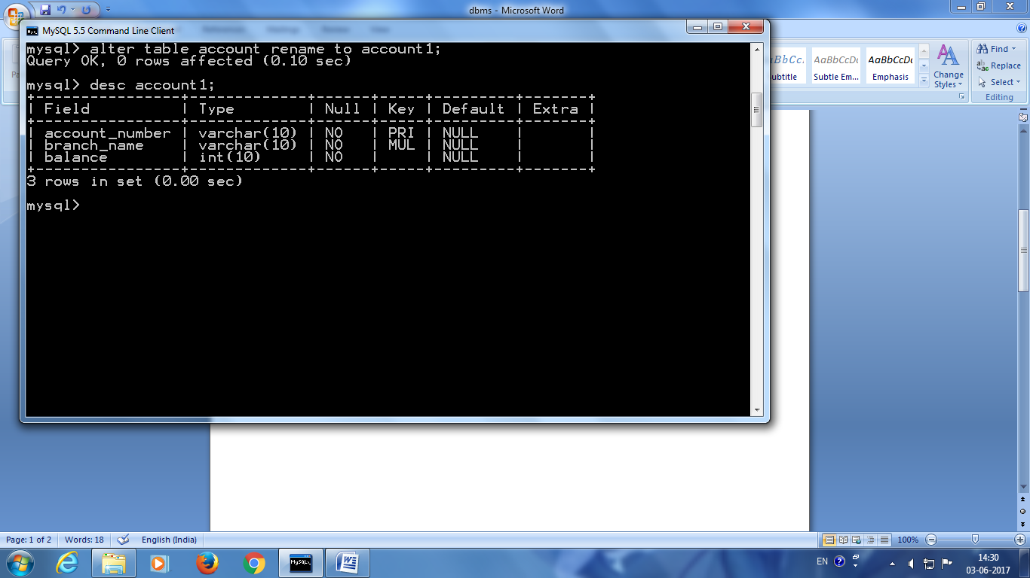

**Table created with primary keys**



**Experiment - Ten**

**(a) Objective:** To study about the DML commands.

**(b)** **Coding & Result :**

**1.Select:**

Syntax:

**Select** A1,A2,…….An

**From** r1,r2,r3…….rn

## Where p

Description: It selects the rows from the table.

**2.Insert**:

Syntax:

**Insert** **into** table-name **values**(value1,value2,…….valuen)

Description: It is used to insert values into specified table.

**3.Delete:**

Syntax:

**Delete** from table-name

**Where** P

Description: It is used to delete the values from specified table.

**5.Group by:**

Syntax:

**Select**  <(columns)>

**From** <(tables)>

**Where** <(condition)>

**Group by** <groupcolumns>

Description: It is used to group the rows that have certain properties and then to apply an aggregate function on one column for each group separately.

**6.OrderBy:**

Syntax:

**Select** [distinct]<columns>

**From** <table>

**Where** <condition>

[**order by** <columns[asc/desc]>]

Description: It is used to retrieve the information stored in database in a particular order.

**Output:**

2. Select loannumber

from loan

where amount between 900 and 1000

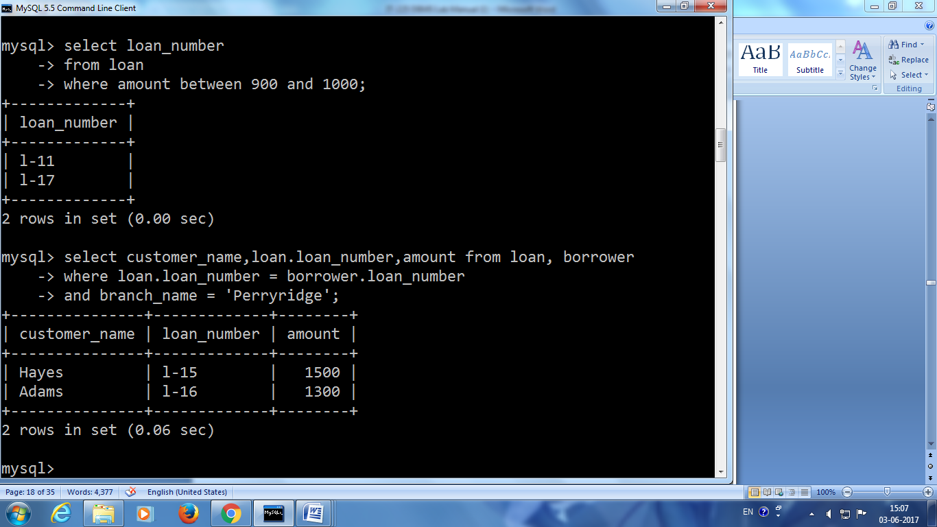

3. Select customername,loan.loannumber,amount

## From loan,Borrower

Where loan.loannumber=Borrower.loannumber and

Branchname = 'Perryridge'

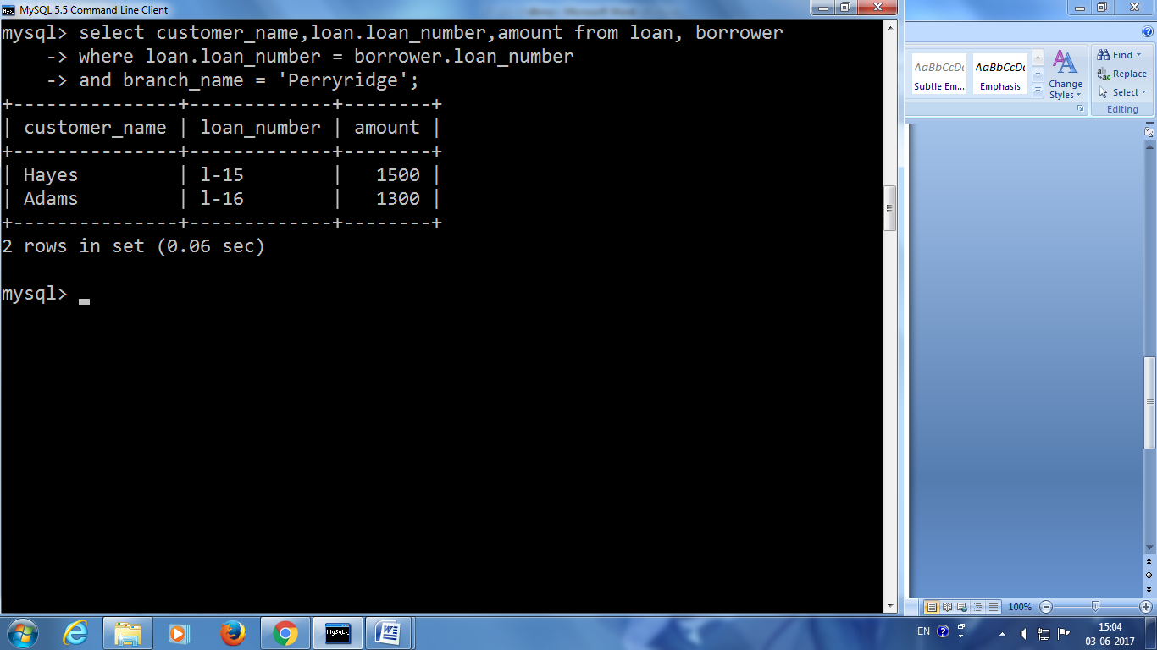

4. select Customername,loannumber

from Borrower

order by Customername

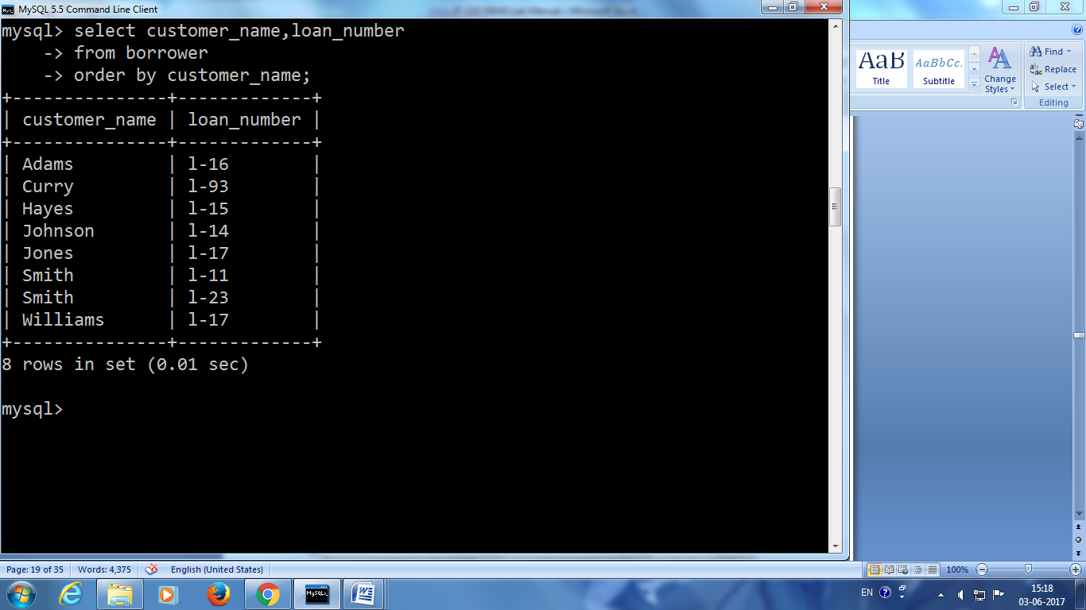

5. Update account Set balance = balance+50 Where branchname='Brighton'

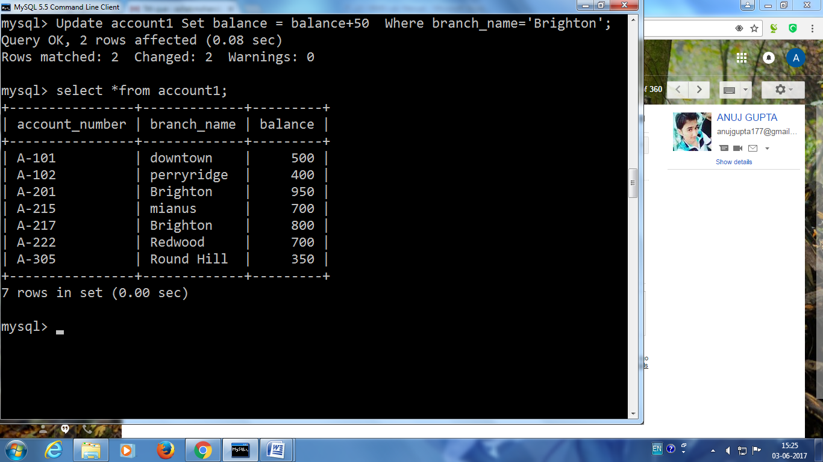

2 rows updated.

select * from account

6. Delete from loan

## Where branchname='Roundhill'

1 row deleted.

Select * from loan

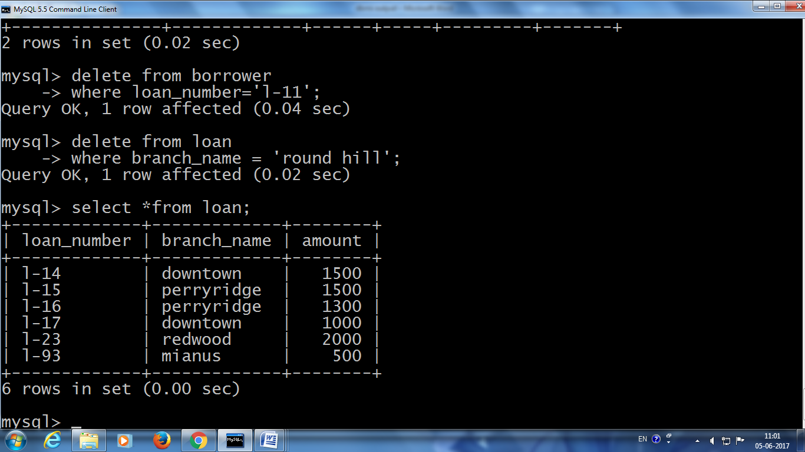

7. select customername

from customer

where customername like '_a%'

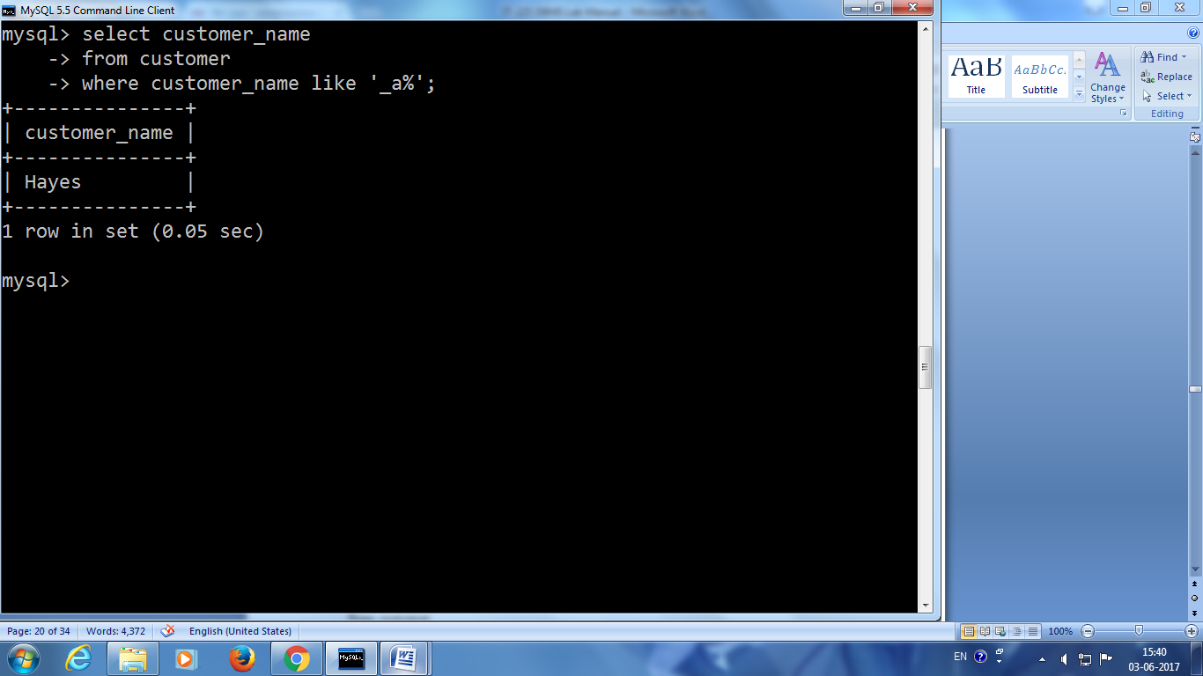

**Experiment - Eleven**

1. **Objective:** To study about the Aggregate Functions.
2. **Coding & Result:**

Count()-To count the number of rows in a table.

Sum()-To find the total value from the row..

Avg()-To find the average value from the row.

Min()-To find the minimum value from the row.

Max()-To find the maximum value from the row.

**Syntax**

**Select** function-name **(A)**

**from** table-name

select * from borrower;

select * from loan;

select * from depositer;

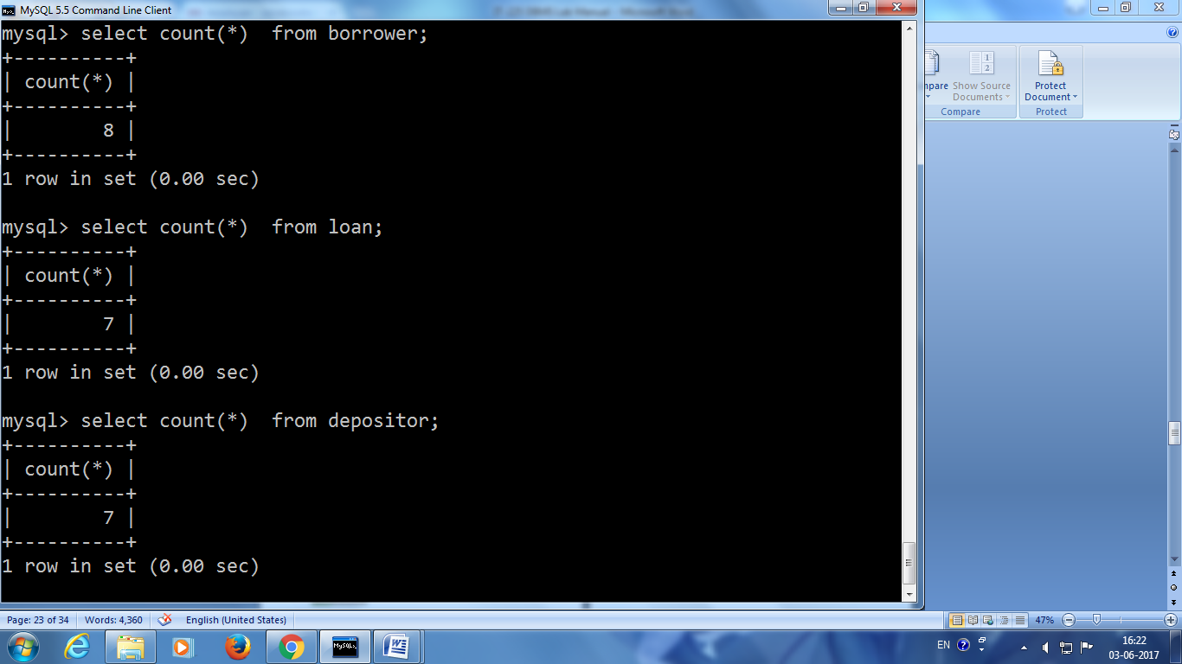

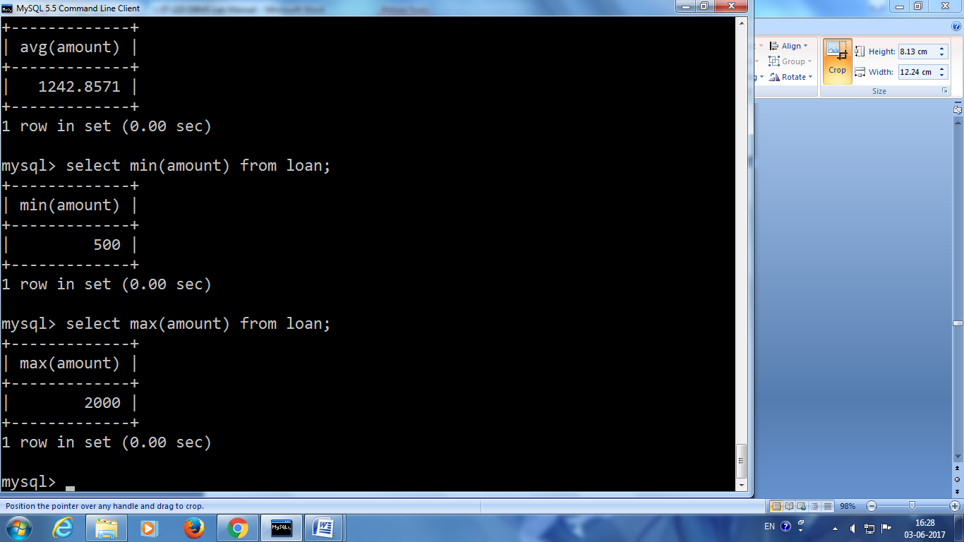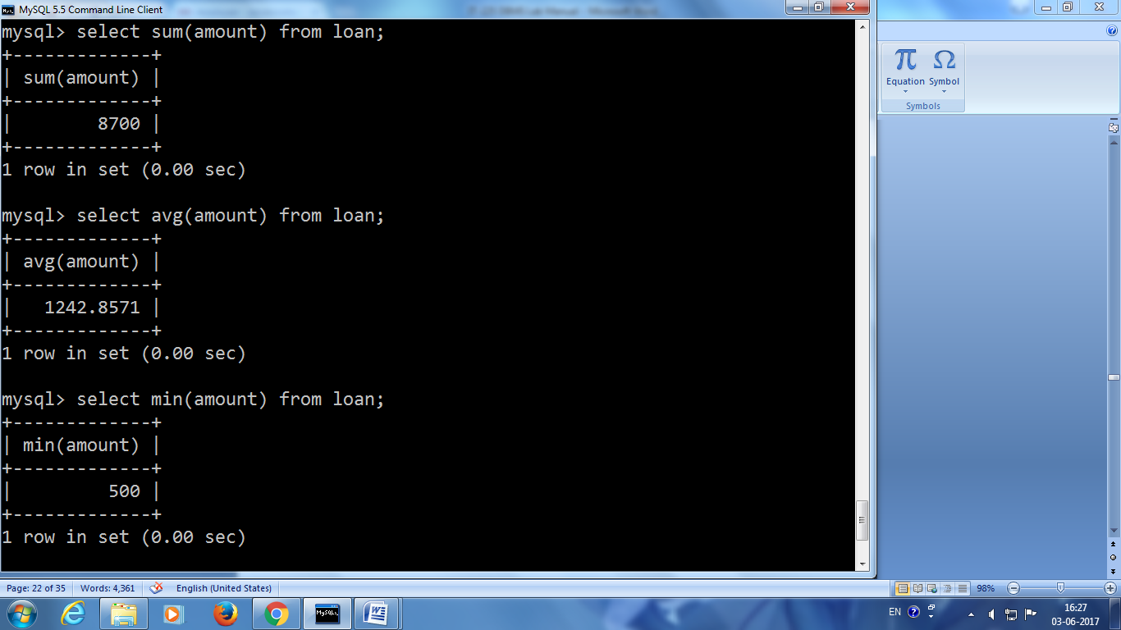

**Experiment - Twelve**

1. **Objective:** To study about the Set Operations.

1. **Coding & Result:**

To find second highest assets values & its corresponding branch name using IN set operator.

**Query:**

**Output:**

**Experiment - Thirteen**

**(a) Objective:** To perform JOIN operations.

**(b)** **Coding & Result :**

**INNER JOIN:**

DESCRIPTION: Returns the matching rows from the tables that are being joined.

**OUTER JOIN:**

SELECT *

FROM<tablename1> join type <tablename2>

ON tablename1.aattribute=tablename2.attribute

**LEFT OUTER JOIN:** Returns the matching row from the table that are being joined and non matching rows from the left table

**RIGHT OUTER JOIN:** Returns the matching row from the table that are being joined and non matching rows from the right table

**FULL OUTER JOIN:** Returns the matching row from the table that are being joined and non matching rows from the left and right table

INITIAL TABLES:

1)Select * from loan

2)select * from borrower

INNER JOIN:

**OUTPUT:** select * from loan inner join borrower on loan.loannumber=borrower.loannumber

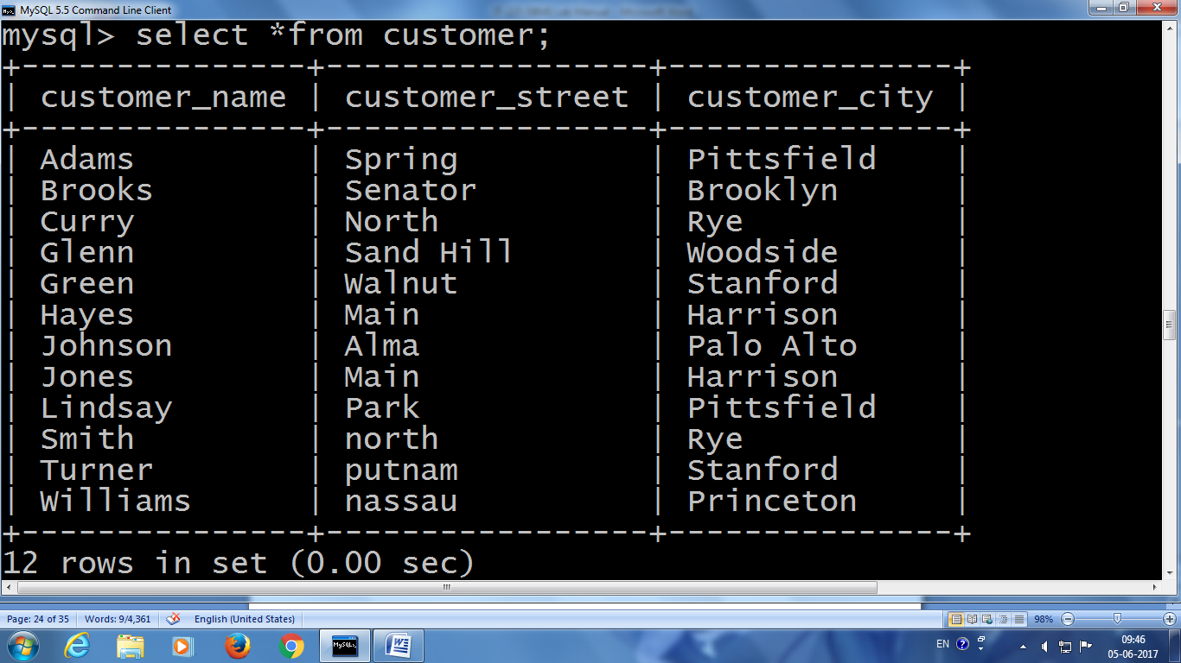

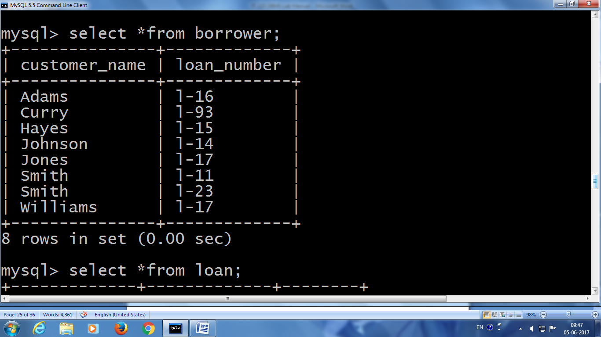

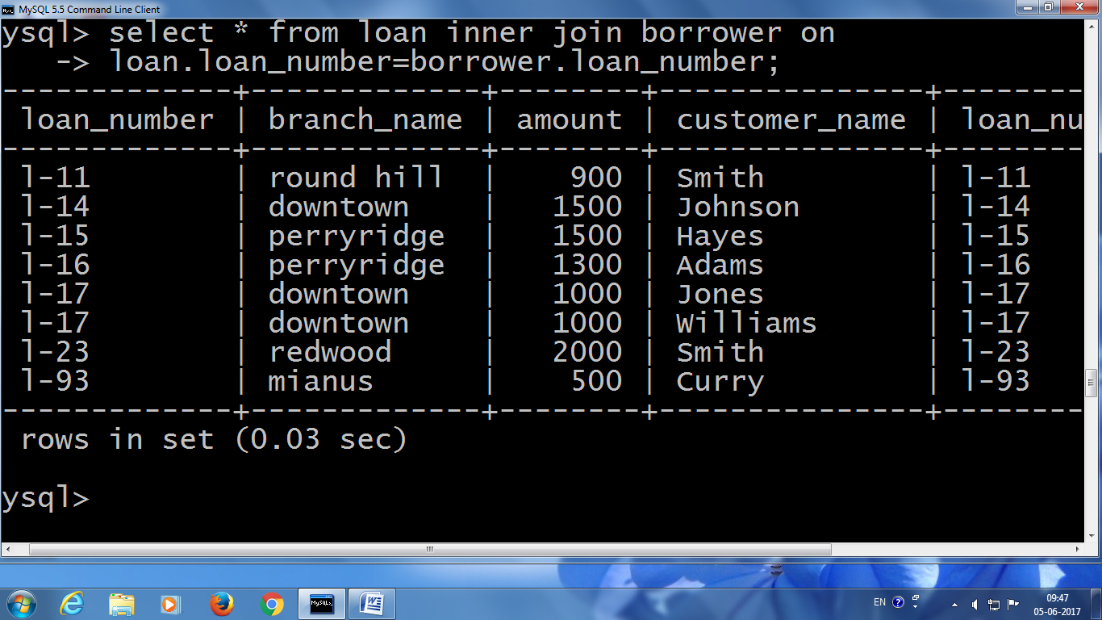

LEFT OUTER JOIN:

**OUTPUT**: select * from loan left outer join borrow on loan.loanno=borrow.loanno

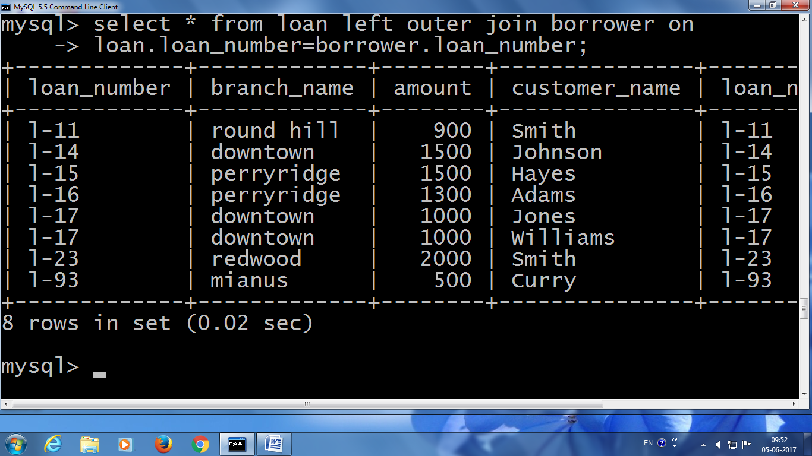

RIGHT OUTER JOIN:

**OUTPUT:** select * from loan right outer join borrow on loan.loanno=borrow.loanno

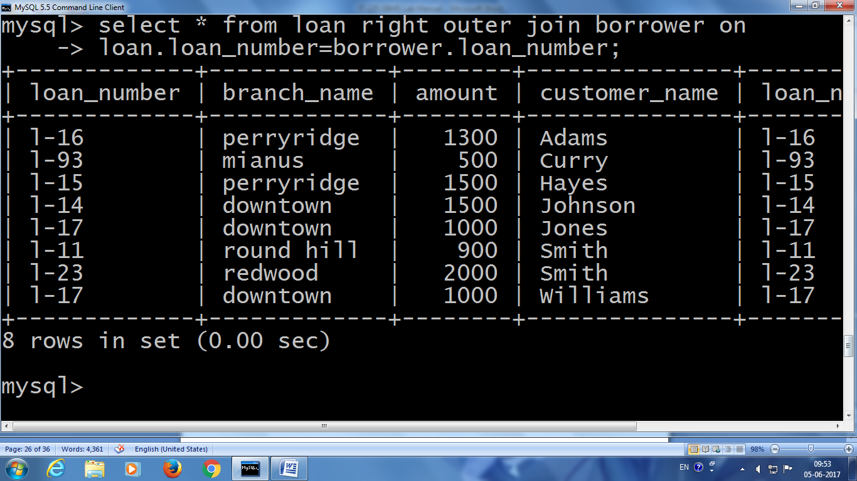

FULL OUTER JOIN:

OUTPUT: select * from loan full outer join borrower on loan.loannumber=borrower.loannumber

RIGHT OUTER JOIN WITH SELECTED ATTRIBUTES:

**OUTPUT:**

select borrow.loanno,cname,amount,bname from loan right outer join borrow on loan.loanno=borrow.loanno

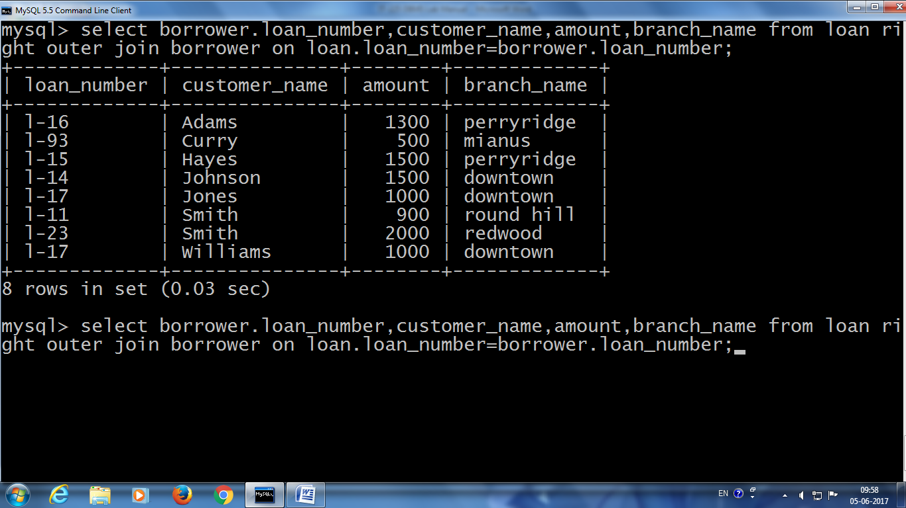

LEFT OUTER JOIN WITH SELECTED ATTRIBUTES:

**OUTPUT:**

select loan.loanno,bname,cname,amount from loan left outer join borrow on loan.loanno=borrow.loanno

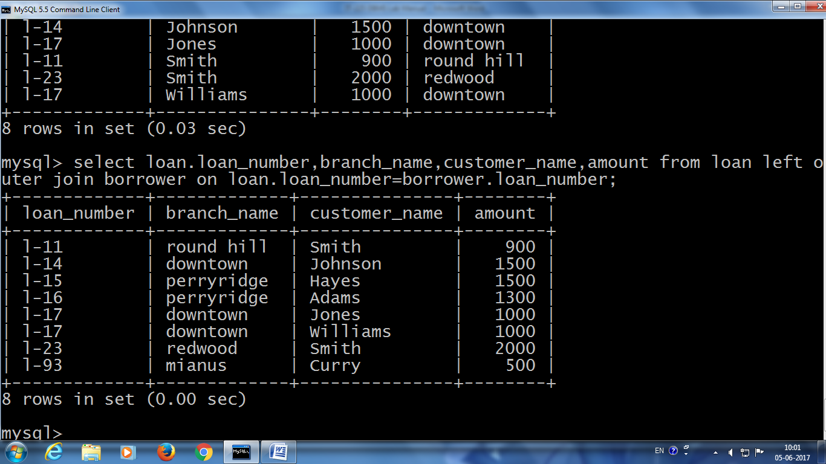

**Experiment – Fourteen**

**(a) Objective:** To study View operations.

**(b)** **Coding & Result :**

SYNTAX:

CREATE or replace view VPS as

SELECT * from branch where branch_name like ‘%t%’ with check option;

OUTPUT:

select*from account;

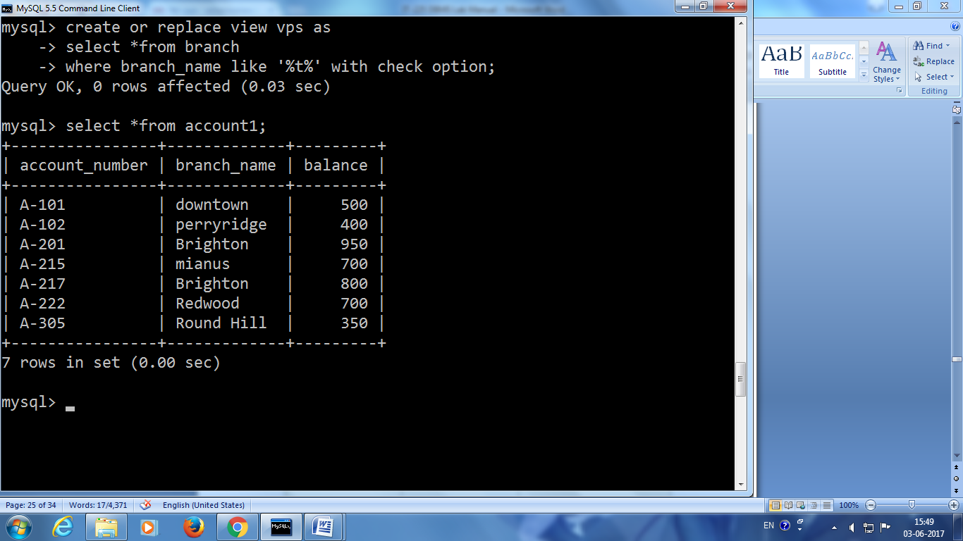

7 rows selected.

**OUTPUT(Snapshot)**

select*from depositor;

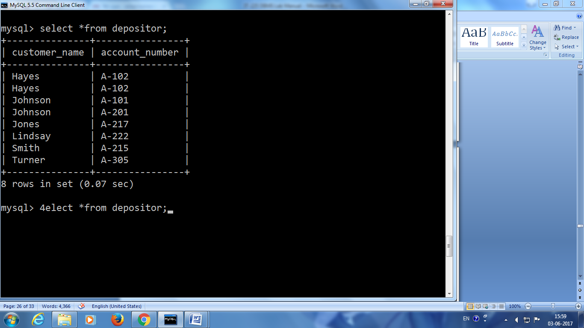

7 rows selected

**OUTPUT: (Snapshot)**

Create a view consisting of branch name and name of customer

create view A1 as(select cname,bname from account,depositor where account.accno=depositor.accno);

view created

select *from A1;

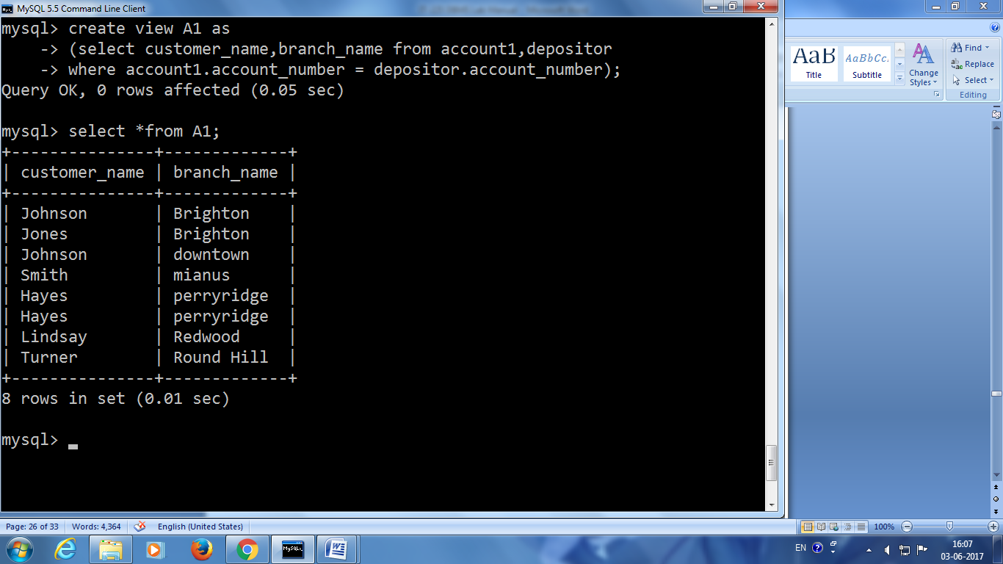

7 rows selected.

OUTPUT:

Select customer name of branch ‘perryridge’ from the view

QUERY :

select cname from a where bname='perryridige’

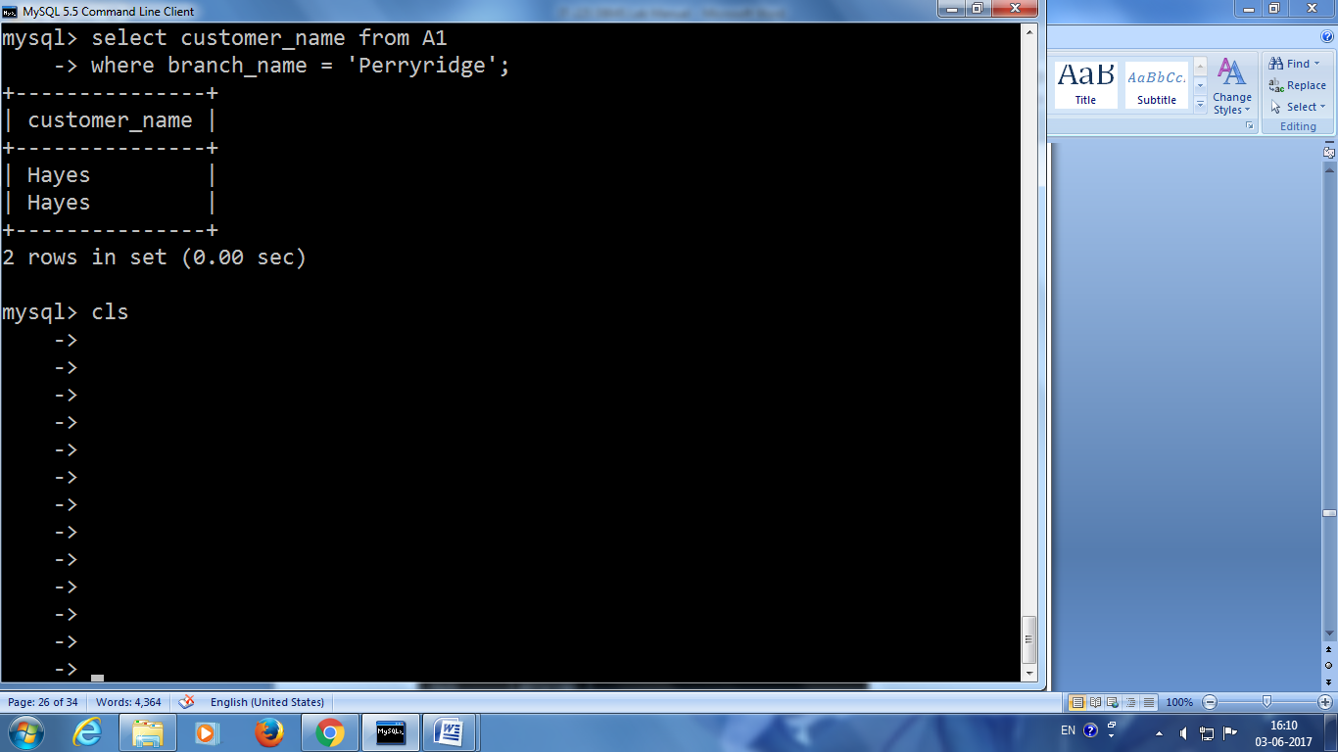

Result:

Thus the join and view operations were performed.

Program1

Table creation

Create table employee(ssn varchar(4),salary int,superssn varchar(4));

Output:

Table created.

Value insertion

insert into employee values('s1',10000,'s3');

insert into employee values('s2',15000,'s3');

insert into employee values('s3',12000,'');

insert into employee values('s4',16000,'s5');

insert into employee values('s5',13000,'');

insert into employee values('s6',11000,'s3');

Output:

1 row created.  
  
1 row created.  
  
1 row created.  
  
1 row created.  
  
1 row created.  
  
1 row created.

Display data stored in the table.

Select * from employee;

Output:

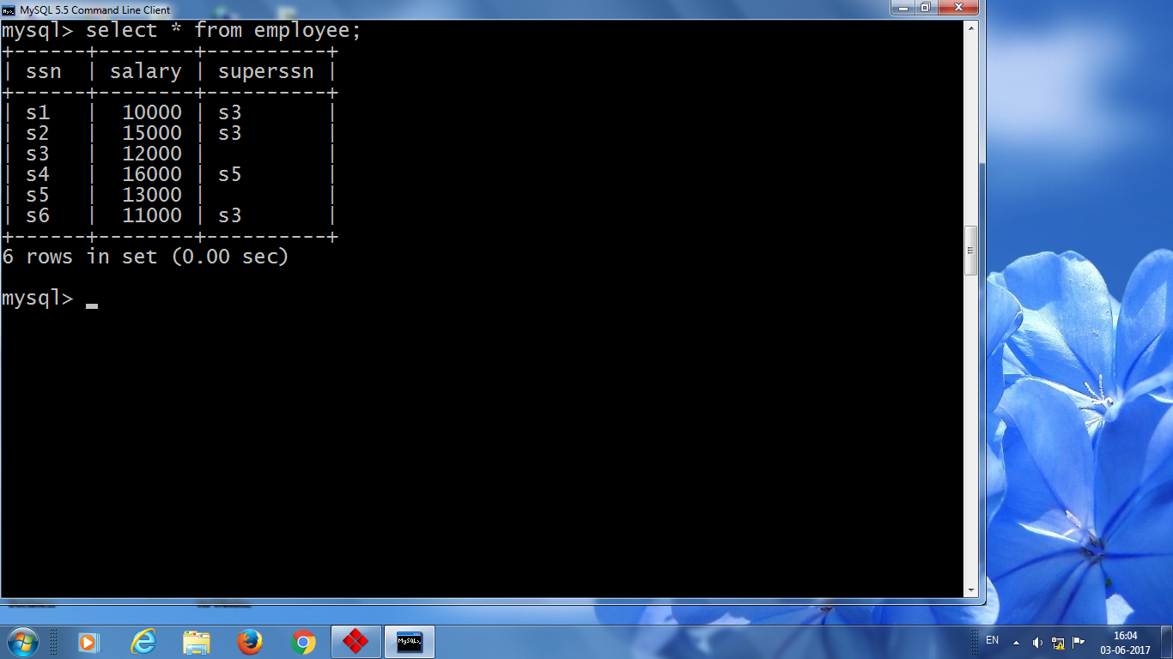

6 rows selected.

**Experiment-15**

**(a) Objective**: To study about the stored procedures.

**(b)** **Coding & Result :**

SYNTAX:

CREATE procedure procedure_name()

SELECT * from branch;

Call procedure_name();

OUTPUT:

SYNTAX:

Create procedure procedure_name (in C varchar(10))

Select * from branch where branch city=c;

Call procedure name (“brooklyn”);

**DBMS Basic VIVA Questions**

1. What is database?

A database is a logically coherent collection of data with some inherent meaning, representing some aspect of real world and which is designed, built and populated with data for a specific purpose.

2. What is DBMS?

It is a collection of programs that enables user to create and maintain a database. In other words it is general-purpose software that provides the users with the processes of defining, constructing and manipulating the database for various applications.

3. What is a Database system?

The database and DBMS software together is called as Database system.

4. What are the advantages of DBMS?

1. Redundancy is controlled.
2. Unauthorised access is restricted.
3. Providing multiple user interfaces.
4. Enforcing integrity constraints.
5. Providing backup and recovery.

5. What are the disadvantage in File Processing System?

1. Data redundancy and inconsistency.
2. Difficult in accessing data.
3. Data isolation.
4. Data integrity.
5. Concurrent access is not possible.
6. Security Problems.

6. Describe the three levels of data abstraction?

The are three levels of abstraction:

1. **Physical level:** The lowest level of abstraction describes how data are stored.
2. **Logical level:** The next higher level of abstraction, describes what data are stored in database and what relationship among those data.
3. **View level:** The highest level of abstraction describes only part of entire database.

7. Define the "integrity rules"?

There are two Integrity rules.

1. **Entity Integrity:** States that "Primary key cannot have NULL value"
2. **Referential Integrity:** States that "Foreign Key can be either a NULL value or should be Primary Key value of other relation.

8. What is extension and intension?

1. **Extension:** It is the number of tuples present in a table at any instance. This is time dependent.
2. **Intension:** It is a constant value that gives the name, structure of table and the constraints laid on it.

9. What is Data Independence?

Data independence means that "the application is independent of the storage structure and access strategy of data". In other words, The ability to modify the schema definition in one level should not affect the schema definition in the next higher level.  
Two types of Data Independence:

1. **Physical Data Independence:** Modification in physical level should not affect the logical level.
2. **Logical Data Independence:** Modification in logical level should affect the view level.

10. What is a view?

A view may be thought of as a virtual table, that is, a table that does not really exist in its own right but is instead derived from one or more underlying base table. In other words, there is no stored file that direct represents the view instead a definition of view is stored in data dictionary.

11. What is Data Model?

A collection of conceptual tools for describing data, data relationships data semantics and constraints.

12. What is E-R model?

This data model is based on real world that consists of basic objects called entities and of relationship among these objects. Entities are described in a database by a set of attributes.

13. What is Object Oriented model?

This model is based on collection of objects. An object contains values stored in instance variables with in the object. An object also contains bodies of code that operate on the object. These bodies of code are called methods. Objects that contain same types of values and the same methods are grouped together into classes.

14. What is an Entity?

It is a 'thing' in the real world with an independent existence.

15. What is an Entity type?

It is a collection (set) of entities that have same attributes.

16. What is an Entity set?

It is a collection of all entities of particular entity type in the database.

17. What is DML (Data Manipulation Language)?

This language that enable user to access or manipulate data as organised by appropriate data model.

1. **Procedural DML or Low level:** DML requires a user to specify what data are needed and how to get those data.
2. **Non-Procedural DML or High level:** DML requires a user to specify what data are needed without specifying how to get those data.

18. What is DML Compiler?

It translates DML statements in a query language into low-level instruction that the query evaluation engine can understand.

19. What is Query evaluation engine?

It executes low-level instruction generated by compiler.

20. What is DDL Interpreter?

It interprets DDL statements and record them in tables containing metadata.

21. What are the different phases of transaction?

Different phases are  
1.) Analysis phase,  
2.) Redo Phase,  
3.) Undo phase.

22. What are the unary operations in Relational Algebra?

PROJECTION and SELECTION.

23. Are the resulting relations of PRODUCT and JOIN operation the same?

No.  
**PRODUCT**: Concatenation of every row in one relation with every row in another.  
**JOIN**: Concatenation of rows from one relation and related rows from another.

24. What is Lossless join property?

It guarantees that the spurious tuple generation does not occur with respect to relation schemas after decomposition.

25. What is 1 NF (Normal Form)?

The domain of attribute must include only atomic (simple, indivisible) values.

26. What is Fully Functional dependency?

It is based on concept of full functional dependency. A functional dependency X Y is full functional dependency if removal of any attribute A from X means that the dependency does not hold any more.

27. What is 2NF?

A relation schema R is in 2NF if it is in 1NF and every non-prime attribute A in R is fully functionally dependent on primary key.

28. What is 3NF?

A relation schema R is in 3NF if it is in 2NF and for every FD X A either of the following is true

1. X is a Super-key of R.
2. A is a prime attribute of R.

In other words, if every non prime attribute is non-transitively dependent on primary key.

29. What is BCNF (Boyce-Codd Normal Form)?

A relation schema R is in BCNF if it is in 3NF and satisfies an additional constraint that for every FD X A, X must be a candidate key.

30. What is Relational Algebra?

It is procedural query language. It consists of a set of operations that take one or two relations as input and produce a new relation.

31. What is Relational Calculus?

It is an applied predicate calculus specifically tailored for relational databases proposed by E.F. Codd. E.g. of languages based on it are DSL ALPHA, QUEL.

32. How does Tuple-oriented relational calculus differ from domain-oriented relational calculus?

1. The **tuple-oriented calculus** uses a tuple variables i.e., variable whose only permitted values are tuples of that relation. E.g. QUEL
2. The **domain-oriented calculus** has domain variables i.e., variables that range over the underlying domains instead of over relation. E.g. ILL, DEDUCE.

33. What is normalization?

It is a process of analysing the given relation schemas based on their Functional Dependencies (FDs) and primary key to achieve the properties  
(1).Minimizing redundancy, (2). Minimizing insertion, deletion and update anomalies.

34. What is Functional Dependency?

A Functional dependency is denoted by X Y between two sets of attributes X and Y that are subsets of R specifies a constraint on the possible tuple that can form a relation state r of R. The constraint is for any two tuples t1 and t2 in r if t1[X] = t2[X] then they have t1[Y] = t2[Y]. This means the value of X component of a tuple uniquely determines the value of component Y.